STD: IV SUB: SOCIAL

LESSON -6

READ THE CLUES AND SOLVE THE PUZZLE
ACROSS

1 The season of roasted groundnuts

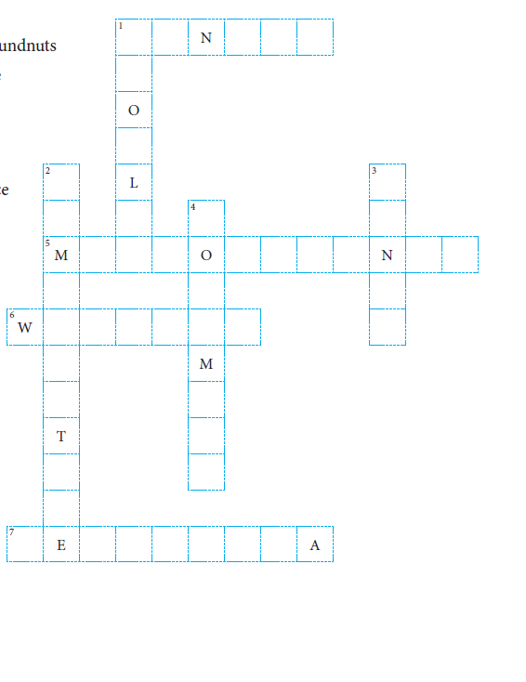
5 Winds that blow from the
Arabian Sea and the
Bay of Bengal during the
Monsoon season

6 Day-to-day conditions of
the air at a particular place

7 A state which receives
about 800 centimetres
of annual rainfall

DOWN

1 The kind of clothes
Worn in winter

2 An important element
that affects climate other
than rainfall

3 A fruit widely
available in
summer

4 The month when
winter begins

STD: IV SUB: SOCIAL
LESSON -6

I.ANSWER IN ONE WORD

1. Regular pattern of weather conditions for about 35 – 40 years.________________.

2. Strong winds that blow from the west and cause snowfall in winter.________________.

3. The season when days are longer than the nights._________________.

4. Hot and dry winds that blow over many parts of north India
in summer.__________________.

5. A sea, other than the Arabian Sea, from which monsoon winds
blow into India.________________.

6. A state where there are parts that receive less than 10 centimetres
of annual rainfall.__________________

II.WRITE TRUE OR FALSE

1. The weather and climate of a place are the same.___________

. 2. The landform of an area influences the weather of that area.___________

3. There are four main seasons in our country._____________

4. It is cold in December in most parts of India.___________

5. Dust storms are common in summer.________________

6. Cherries are available during the monsoon season_______________

III.WRITE SHORT ANSWERS

1. Write the names of two elements that affect the climate.

__________________________________________________________________

2. How many seasons are there in India? Write their names.

__________________________________________________________________

__________________________________________________________________

3. What type of weather do the coastal areas experience in winter?

__________________________________________________________________

__________________________________________________________________

4. In which months does the coast of Tamil Nadu receives rainfall?

__________________________________________________________________

__________________________________________________________________

